Pendulums: Behind the Science

Pendulums are a lot like waves. Pendulums experience “periodic motion”, a type of motion that follows an exact, repeating cycle. The Earth going around the Sun is an example of periodic motion… it takes the Earth 1 year to go around and return to where it was a year earlier. Studying pendulums to learn about periodic motion is an important step in understanding wave motion.
Work in groups of two. You will need a small washer to serve as the pendulum “bob”, a piece of string about 1 meter long, a meter stick (which you can share), a stopwatch (use the one on your phone), tape, and lots of focus.

I). Procedure
-Make a pendulum that is about 10 cm long by tying one end of your string to your little mass, and then taping the string to the bottom of your table top so that the middle of the pendulum bob (the hanging mass) is 10 cm below the bottom edge of the table.
-Let the mass hang down from the string, and then pull the mass about one inch to the side and let it go... watch it swing!!!
-Using a stopwatch, determine the amount of time needed for the pendulum to complete 10 FULL swings (back AND forth), and record the time in the space below.

Time to complete 10 pendulum swings = ________ seconds.

The period of the pendulum is the time that it takes for the pendulum to complete one full back-and-forth swing. Since you found the time that it took for the pendulum to complete 10 swings, you can find the Period of your pendulum by dividing the time for 10 swings by the number of swings (10).

Period of a 10 cm pendulum = (time to complete 10 swings)/10

= (___________ seconds)/10

= ____________ seconds
Repeat your investigation with the 10cm long pendulum: find the time needed to complete 10 swings, then divide by 10 to calculate the period (time to complete 1 swing).

Trial 2 for 10 cm pendulum:

Time to finish 10 swings = __________ seconds

Period = _______ seconds

Trial 3 for 10 cm pendulum:

Time to finish 10 swings = __________ seconds

Period = _______ seconds

Now let’s find the average of the three periods that you calculated. To do this, add the three periods together, then divide by three:

Average Period = (Trial 1 period + Trial 2 period + Trial 3 period)/3

= ( __________ + __________ + __________)/3

= (__________)/3

= __________ seconds

The PERIOD of a pendulum swing tells us

_________________________________________________________

_________________________________________________________
-Enter the numbers that you have calculated for the 10 cm period into the data table on the next page.

-Change the length of string hanging below the table so that the pendulum is 20 cm long, and repeat the experiment (3 trials), recording your data and calculations in the table. Repeat the experiment until you have found the period and frequency of pendulums that are 10 cm, 20 cm, 30 cm, 40 cm, and 50 cm in length. Now, repeat the experiment by pulling the washer 4 inches to the side and releasing... determine the period of this pendulum.

Data and Results Table for Pendulum Experiment

Pendulum Length | Trial 1 | Trial 2 | Trial 3 | Average
10 cm
Time for 10 swings (sec)

Period (time for 1 swing)

20 cm
Time for 10 swings (sec)

Period (time for 1 swing)

30 cm
Time for 10 swings (sec)

Period (time for 1 swing)

40 cm
Time for 10 swings (sec)

Period (time for 1 swing)

50 cm
Time for 10 swings (sec)

Period (time for 1 swing)

Graphing our Results

The next step in our exploration of pendulums is to graph our results so that we can see trends in the relationship between pendulum length and period.

Let’s graph our results for the period of the pendulums. Examine the graph below. On the horizontal (X) axis, is pendulum length. On the vertical (Y) axis, we have the period of the pendulum.

For each of the 5 pendulum lengths that you collected data on, plot the AVERAGE Period vs Length on the graph below.
Period in seconds
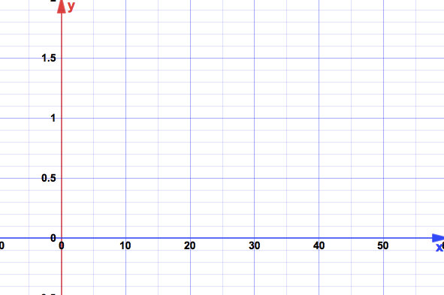
Pendulum Length in cm

Question: What is the trend that you see in the relationship between the length of the pendulum and the period of the pendulum?

As the length of the pendulum increases, …

